Game Design Document

Fill up the Following document

1. Write the title of your project.

THE DEVILS GARAGE.

1. What is the goal of the game?

The goal is to collect all the gems which are spread around the maze.

1. Write a brief story of your game?

The hero was told to bring the gems which were stolen by the bad guys. When the hero enters the maze the ghosts try to attack the hero and the hero will escape and collect all the gems. The score will increase by collecting the gems.

1. Which are the playing characters of this game?

* Playing characters are the ones which respond to the user based on the input from the user
* Cars, monkeys, dinos, wizards etc, are the playing characters in the game.

|  |  |  |
| --- | --- | --- |
| Number | Character Name | What can this character do? |
| 1 | Hero | He can move in all directions i.e., Left, Right, Up , Down. |
| 2 | Enemy 1 | Go around the maze and the hero |
| 3 | Enemy 2 | Go around the maze and the hero |
| 4 |  |  |
| 5 |  |  |
| 6 |  |  |
| 7 |  |  |
| 8 |  |  |

1. Which are the Non Playing Characters of this game?

* Non Playing characters are the ones which don't have an action or a behaviour when the user interacts with the game.
* Hurdles, stones, bananas, coins, etc are non playing characters in the game.

|  |  |  |
| --- | --- | --- |
| Number | Character Name | What can this character do? |
| 1 | Bombs | They blast when the player touches it. |
| 2 | Gems | They will be collected by the hero. |
| 3 |  |  |
| 4 |  |  |
| 5 |  |  |
| 6 |  |  |
| 7 |  |  |
| 8 |  |  |

Draw your imagination of this game. What does this game look like?

* Draw the game either on your computer or on paper,
* Add images of scenes of the game to show each of the playing and non-playing characters at least once.

1. **THE DEVILS GARAGE** 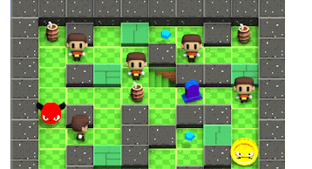

How do you plan to make your game engaging?

I will engage the Hero to collect all the gems which are spread around the maze and he will also need to escape from the ghosts and kill them.